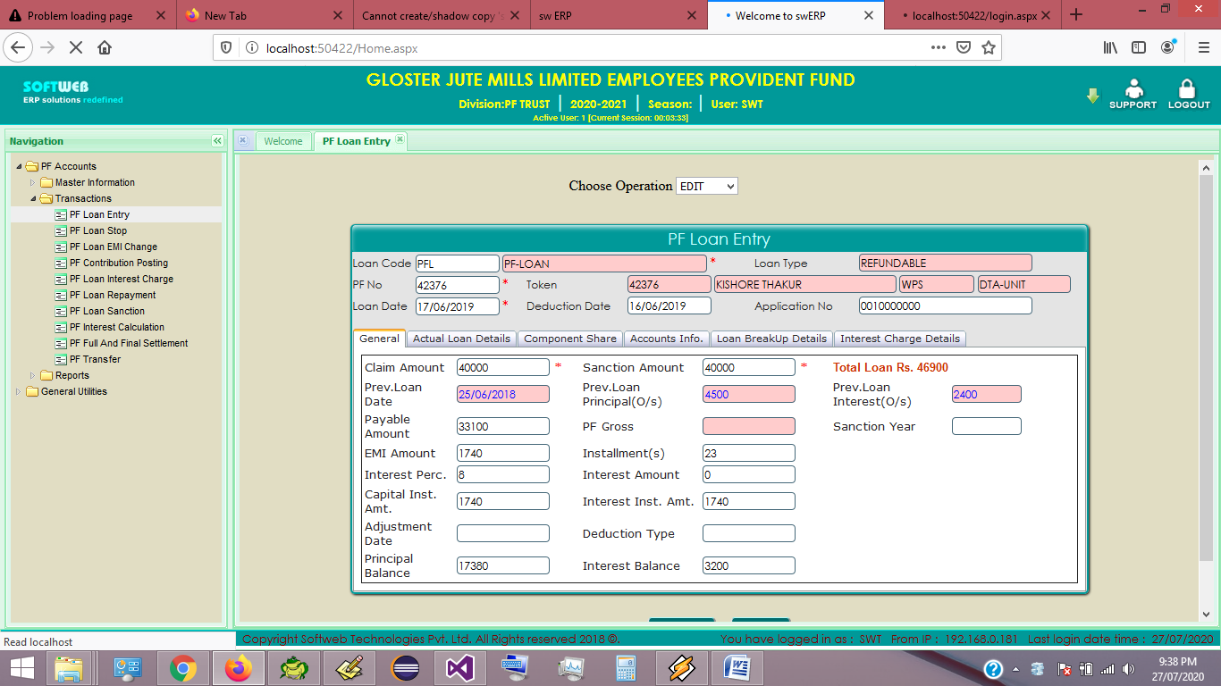

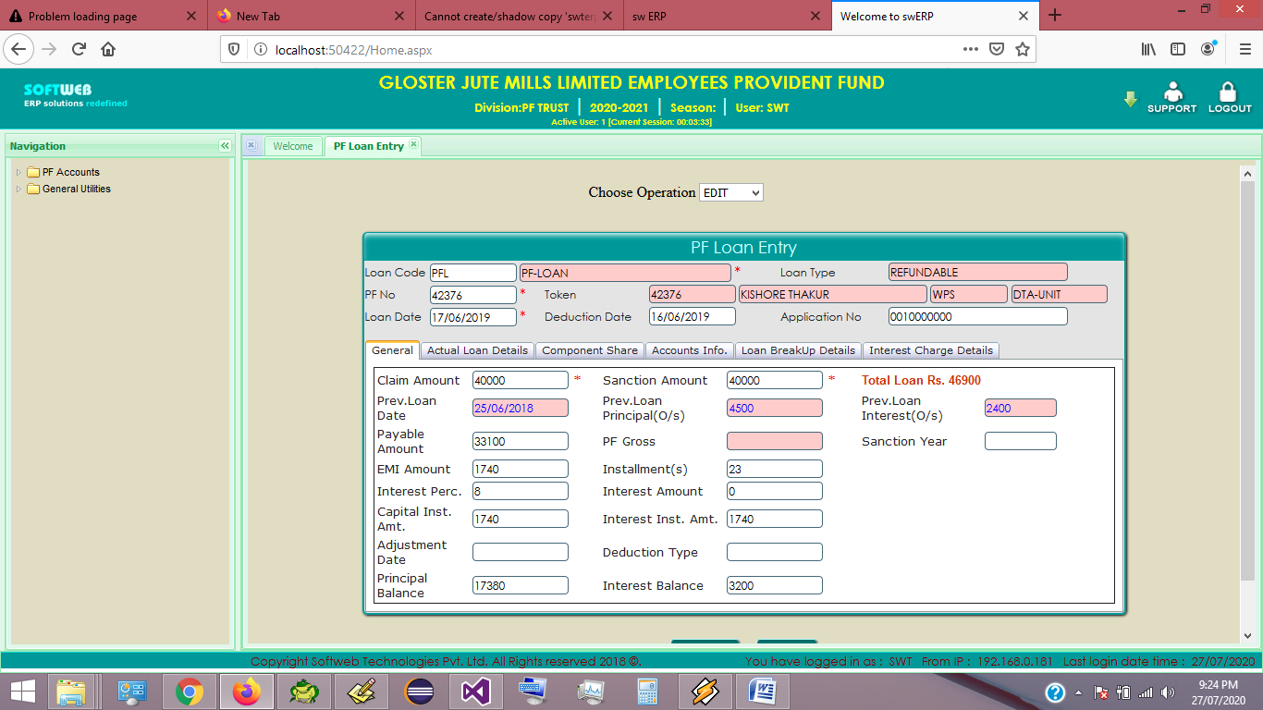

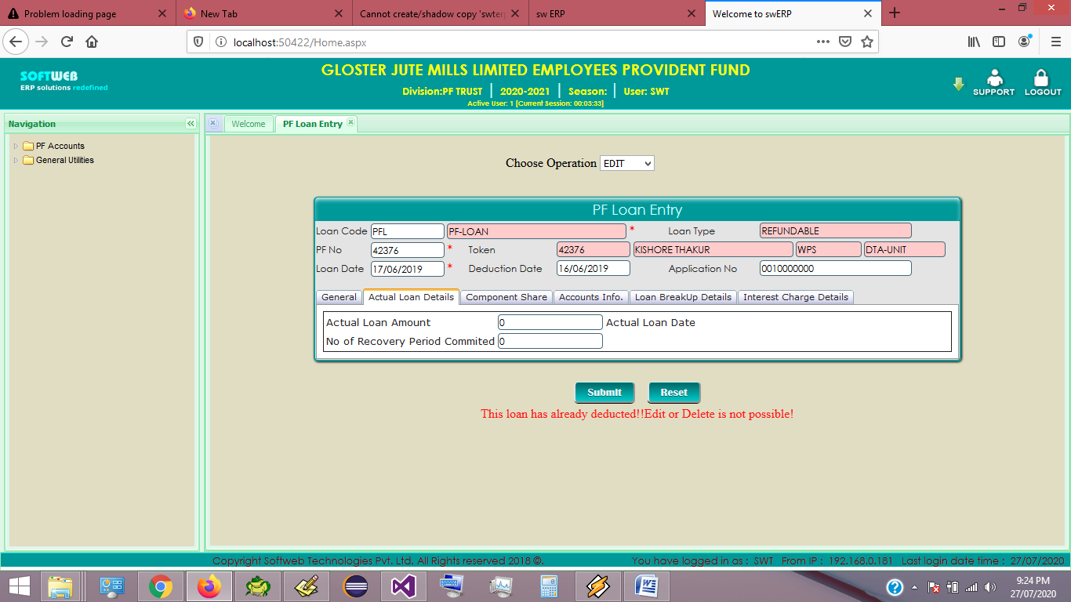

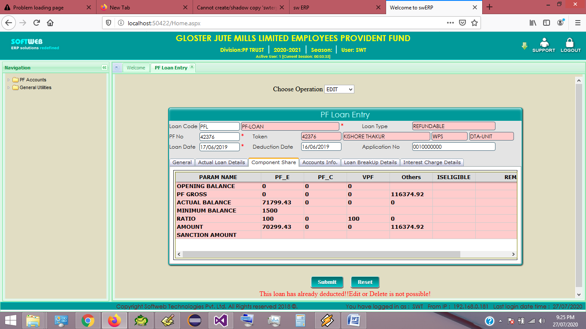

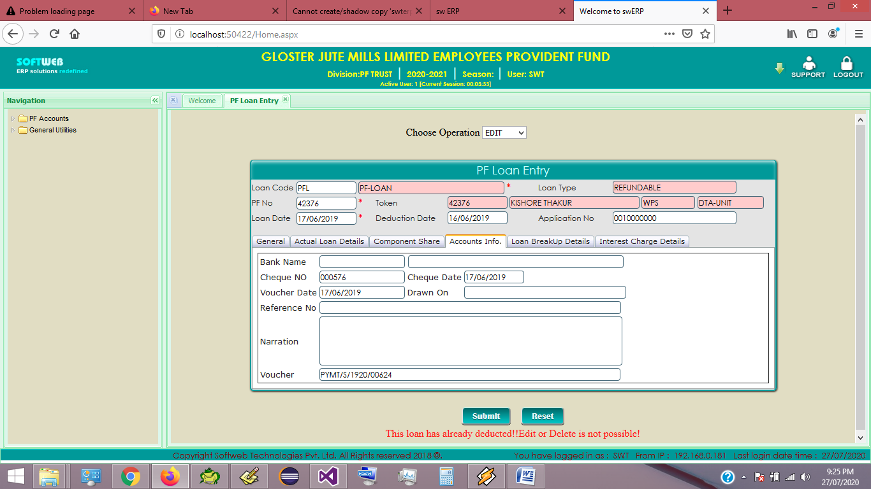

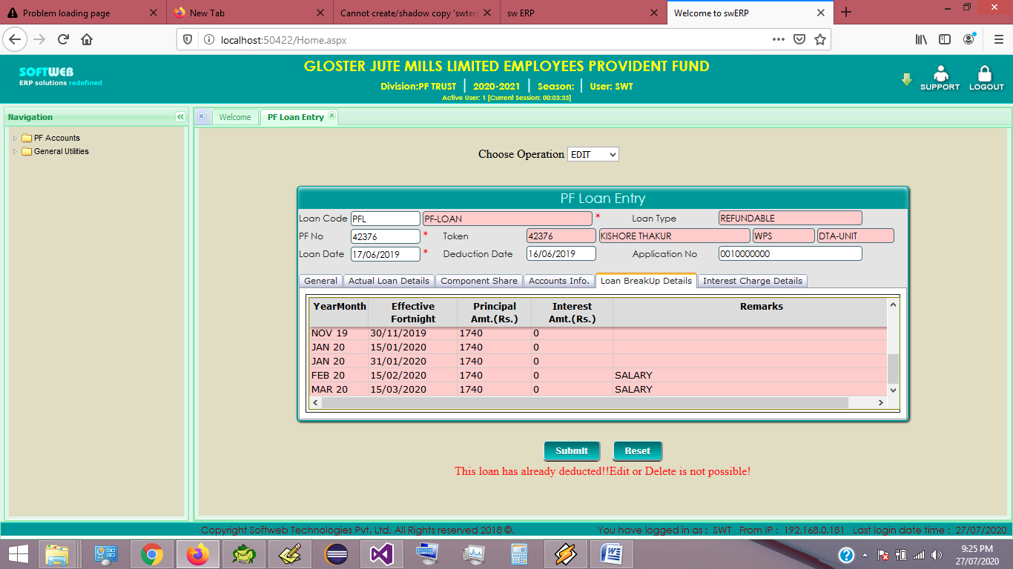

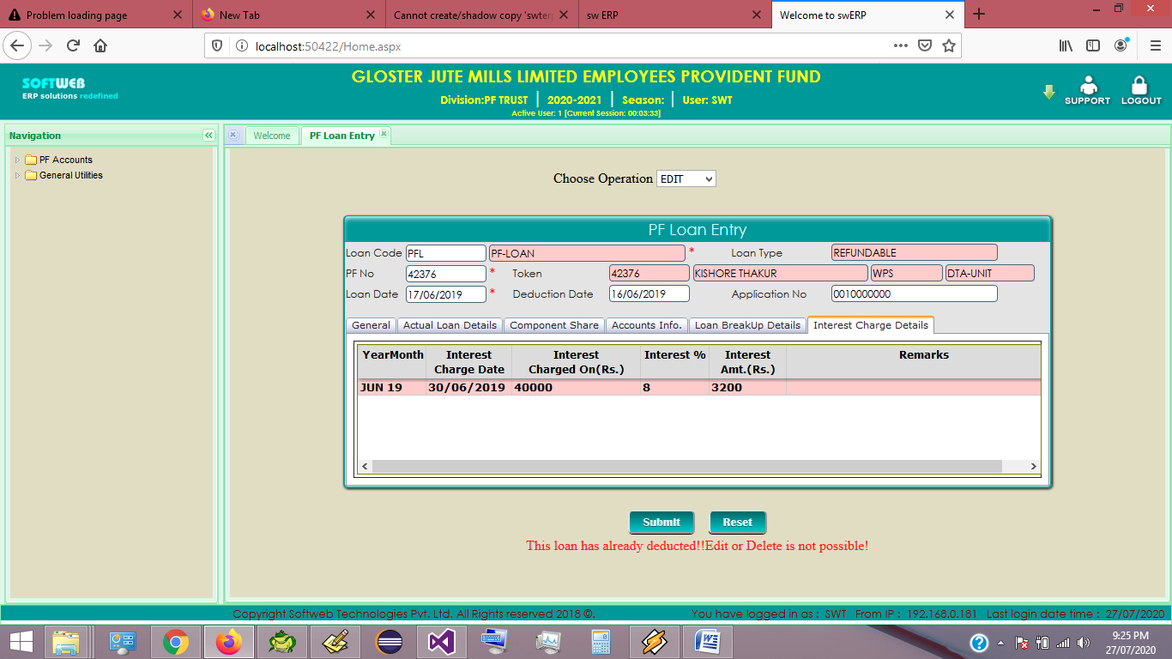

Task List

PF LOAN ENTRY INTERFACE

----------------------------------------------------------------------

1. Select Loan code

Fetch Loan Details data

----------------------------------------------------------------------

2. Select PF No or Token No

Fetch Employee Details

----------------------------------------------------------------------

3. Put Loan Date

After Loan Entered do the following task....

i. Check Applied Loan Date already entered on this date

ii. Load Component Share Grid

iii. Fetch Previous Loan Balance

iV.

----------------------------------------------------------------------

4. Put Claim Amount

After Loan Claim Amount given

i. Check Sanction Amount

----------------------------------------------------------------------

5. Put Loan Sanction Year

After putting Sanction Year

i. Change No. of Installment

(WPS ---> 1 year = 25 installments)

(PIS ---> 1 year = 12 installments)

Calculation EMI amount

----------------------------------------------------------------------

----------------------------------------------------------------------

----------------------------------------------------------------------

CREATE OR REPLACE PROCEDURE GLOSTER_WEB.PRC_PF_COMPONENT_SHARE

(

p_companycode varchar2,

p_divisioncode varchar2,

p_yearcode varchar2,

p_workerserial varchar2,

p_loancode varchar2,

p_loandate varchar2,

OPTMODE VARCHAR2

)

as

lv_output VARCHAR2(4000);

lv_query VARCHAR2(4000);

lv_query2 VARCHAR2(4000);

lv_PFNO VARCHAR2(10);

lv_FUNCTION VARCHAR2(4000);

lv_TOKENNO VARCHAR2(10);

lv_FNSTDT VARCHAR2(11);

lv_FNENDT VARCHAR(11);

lv_EMP_COMCODE VARCHAR2(10);

lv_EMP_DIVCODE VARCHAR2(10);

BEGIN

SELECT TOKENNO,PFNO,CURRENTCOMPANYCODE, CURRENTDIVISIONCODE

INTO lv_TOKENNO,lv_PFNO,lv_EMP_COMCODE,lv_EMP_DIVCODE

FROM PFEMPLOYEEMASTER

WHERE WORKERSERIAL=p_workerserial;

DELETE FROM GTT_LOANSANCTION_PRAM;

SELECT FN_GETFORTNIGHTSTARTENDDATE(p_loandate,'START') INTO lv_FNSTDT FROM DUAL;

SELECT FN_GETFORTNIGHTSTARTENDDATE(p_loandate,'END') INTO lv_FNENDT FROM DUAL;

PROC_WPSVIEWCREATION ( lv_EMP_COMCODE,lv_EMP_DIVCODE,'MAST',0,lv_FNSTDT,lv_FNENDT);

PRC_PISVIEWCREATION(lv_EMP_COMCODE,lv_EMP_DIVCODE,'PISASSIGN',0,TO_CHAR(TO_DATE(p_loandate,'DD/MM/YYYY'),'YYYYMM'),TO_CHAR(TO_DATE(p_loandate,'DD/MM/YYYY'),'YYYYMM'));

lv_query:='INSERT INTO GTT_LOANSANCTION_PRAM'||chr(10)

||'(COMPANYCODE, DIVISIONCODE, YEARCODE,PFNO,TOKENNO , WORKERSERIAL, LOANDATE, LOANCODE,PARAM_NAME,PF_E,PF_C , VPF,OTHER )'||chr(10)

||'SELECT '''||p_companycode||''' COMPANYCODE,'''||p_divisioncode||''' DIVISIONCODE ,'||CHR(10)

||''''||p_yearcode||''' YEARCODE,'''||lv_PFNO||''' PFNO,'''||lv_TOKENNO||''' TOKENNO ,'||CHR(10)

||''''||p_workerserial||''' WORKERSERIAL,TO_DATE('''||p_loandate||''',''DD/MM/YYYY'') LOANDATE,'''||p_loancode||''' LOANCODE,PARAM_NAME,'||CHR(10)

||'NULL PF_E,NULL PF_C ,NULL VPF,NULL OTHER '||CHR(10);

lv_query:=lv_query ||' FROM SYS_SWT_PF_LOAN_SANCTION_PARAM'||CHR(10)

||'WHERE LOANCODE='''||p_loancode||''''||CHR(10)

--||'GROUP BY PARAM_NAME'||CHR(10)

||'order BY PIORITY_INDEX';

--DBMS_OUTPUT.PUT_LINE(lv_query);

execute IMMEDIATE lv_query;

for c2 in(SELECT * FROM SYS_SWT_PF_LOAN_SANCTION_PARAM WHERE COMPANYCODE=p_companycode /*AND DIVISIONCODE=p_divisioncode*/ AND LOANCODE = p_loancode order BY PIORITY_INDEX /*WHERE APPLICABLE_COMPONENT='PF_E'*/)

loop

IF c2.HELP_QRY IS NOT NULL THEN

lv_query2:=REPLACE(REPLACE(REPLACE(REPLACE(REPLACE(REPLACE(c2.HELP_QRY,'<<COMPANYCODE>>',p_companycode),'<<DIVISIONCODE>>',p_divisioncode),'<<YEARCODE>>',p_yearcode), '<<PFNO>>',lv_PFNO),'<<LOANCODE>>',p_loancode),'<<LOANDATE>>',p_loandate);

DBMS_OUTPUT.PUT_LINE(lv_query2);

IF c2.APPLICABLE_COMPONENT='COMMON' THEN

EXECUTE IMMEDIATE lv_query2 INTO lv_output;

EXECUTE IMMEDIATE lv_output;

elsif c2.APPLICABLE_COMPONENT='COMMON2' THEN

EXECUTE IMMEDIATE lv_query2;

ELSE

IF c2.HELP_QRY IS NOT NULL THEN

EXECUTE IMMEDIATE lv_query2 INTO lv_output;

lv_query:='UPDATE GTT_LOANSANCTION_PRAM SET '||c2.APPLICABLE_COMPONENT||' = '''||lv_output||''' WHERE PARAM_NAME = '''||c2.PARAM_NAME||'''';

EXECUTE IMMEDIATE lv_query;

END IF;

END IF;

UPDATE GTT_LOANSANCTION_PRAM SET TABINDEX=C2.PIORITY_INDEX WHERE PARAM_NAME=c2.PARAM_NAME;

ELSE

IF OPTMODE='A' THEN

lv_FUNCTION:='SELECT '||REPLACE(REPLACE(REPLACE(REPLACE(REPLACE(REPLACE(c2.PROC_NAME,'<<COMPANYCODE>>',p_companycode),'<<DIVISIONCODE>>',p_divisioncode),'<<YEARCODE>>',p_yearcode), '<<PFNO>>',lv_PFNO),'<<LOANCODE>>',p_loancode),'<<LOANDATE>>',p_loandate)||' FROM DUAL';

DBMS_OUTPUT.PUT_LINE(lv_FUNCTION);

EXECUTE IMMEDIATE lv_FUNCTION INTO lv_output;

IF lv_output='Y' THEN

lv_query:='UPDATE GTT_LOANSANCTION_PRAM SET ISELLIGIBLE = '''||lv_output||''' WHERE PARAM_NAME = '''||c2.PARAM_NAME||'''';

EXECUTE IMMEDIATE lv_query;

ELSE

lv_query:='UPDATE GTT_LOANSANCTION_PRAM SET ISELLIGIBLE = ''N'',REMARKS='''||lv_output||''' WHERE PARAM_NAME = '''||c2.PARAM_NAME||'''';

EXECUTE IMMEDIATE lv_query;

RETURN;

END IF;

UPDATE GTT_LOANSANCTION_PRAM SET TABINDEX=C2.PIORITY_INDEX WHERE PARAM_NAME=c2.PARAM_NAME;

END IF;

END IF;

end loop;

END;

/

CREATE OR REPLACE FUNCTION FN_GET_QRYSTRING

(

P_PARAMS VARCHAR2,

P_QUERY VARCHAR2

)

RETURN VARCHAR2

AS

LV_RESULT VARCHAR2(4000);

BEGIN

LV_RESULT := P_QUERY;

--LV_PARAMS := 'COMPANYCODE:0001~DIVISIONCODE:0002';

--LV_QRY := 'SELECT <<COMPANYCODE>>,<<DIVISIONCODE>> FROM DUAL';

--SELECT FN_GET_QRYSTRING('COMPANYCODE:0001~DIVISIONCODE:0002','SELECT <<COMPANYCODE>>,<<DIVISIONCODE>> FROM DUAL') FROM DUAL

FOR C1 IN

(

SELECT REC1,SUBSTR(REC1,0,INSTR(REC1,':')-1) PARAMNAME,

SUBSTR(REC1,INSTR(REC1,':')+1, LENGTH(REC1)) PARAMVALUE

FROM

(

SELECT REGEXP_SUBSTR(P_PARAMS,'[^~]+', 1, LEVEL) REC1

FROM DUAL

CONNECT BY REGEXP_SUBSTR(P_PARAMS, '[^~]+', 1, LEVEL)

IS NOT NULL

)

)

LOOP

LV_RESULT := REPLACE(LV_RESULT,'<<'||C1.PARAMNAME||'>>',C1.PARAMVALUE);

END LOOP;

RETURN LV_RESULT;

END;

/

CREATE OR REPLACE FUNCTION FN_GET_PARAMVALUE

(

P_PARAMS VARCHAR2,

P_PARAMNAME VARCHAR2

)

RETURN VARCHAR2

AS

LV_RESULT VARCHAR2(4000);

BEGIN

LV_RESULT := NULL;

--SELECT FN_GET_PARAMVALUE('COMPANYCODE:0001~DIVISIONCODE:0002','COMPANYCODE') FROM DUAL

SELECT PARAMVALUE INTO LV_RESULT FROM (

SELECT REC1,SUBSTR(REC1,0,INSTR(REC1,':')-1) PARAMNAME,

SUBSTR(REC1,INSTR(REC1,':')+1, LENGTH(REC1)) PARAMVALUE

FROM

(

select regexp_substr(P_PARAMS,'[^~]+', 1, level) REC1

from dual

connect BY regexp_substr(P_PARAMS, '[^~]+', 1, level)

is not null

)

)

WHERE PARAMNAME=P_PARAMNAME;

RETURN LV_RESULT;

EXCEPTION WHEN OTHERS THEN

LV_RESULT := NULL;

RETURN LV_RESULT;

END;

/

DROP TABLE SYS_SWT_PF_LOAN_SANCTION_PARAM CASCADE CONSTRAINTS;

CREATE TABLE SYS_SWT_PF_LOAN_SANCTION_PARAM

(

COMPANYCODE VARCHAR2(10 BYTE),

DIVISIONCODE VARCHAR2(10 BYTE),

LOANCODE VARCHAR2(10 BYTE),

PARAM_NAME VARCHAR2(100 BYTE),

PARAM_DESC VARCHAR2(100 BYTE),

APPLICABLE_COMPONENT VARCHAR2(10 BYTE),

PROC_NAME VARCHAR2(200 BYTE),

HELP_QRY VARCHAR2(4000 BYTE),

PIORITY_INDEX NUMBER(3)

)

--INSERT SCRIPT

SET DEFINE OFF;

Insert into SYS_SWT_PF_LOAN_SANCTION_PARAM

(COMPANYCODE, DIVISIONCODE, LOANCODE, PARAM_NAME, PARAM_DESC,

APPLICABLE_COMPONENT, PROC_NAME, HELP_QRY, PIORITY_INDEX)

Values

('0002', '0010', 'PFL', 'PF GROSS', 'PF GROSS',

'OTHER', NULL, 'SELECT FN_PFGROSS_FOR_PFLOAN(''<<COMPANYCODE>>'',''<<DIVIISIONCODE>>'',''<<PFNO>>'',''<<LOANDATE>>'')*12 FROM DUAL ', 3);

Insert into SYS_SWT_PF_LOAN_SANCTION_PARAM

(COMPANYCODE, DIVISIONCODE, LOANCODE, PARAM_NAME, PARAM_DESC,

APPLICABLE_COMPONENT, PROC_NAME, HELP_QRY, PIORITY_INDEX)

Values

('0002', '0010', 'PFL', 'MINIMUM BALANCE', 'MINIMUM BALANCE',

'PF_E', NULL, ' SELECT DISTINCT MINBALANCE'||CHR(10)||' FROM PFLOANMASTER'||CHR(10)||' WHERE COMPANYCODE = ''<<COMPANYCODE>>'''||CHR(10)||' --AND DIVISIONCODE = ''<<DIVISIONCODE>>'''||CHR(10)||' AND LOANCODE = ''<<LOANCODE>>'''||CHR(10)||' AND AGAINSTCOMPONENT=''PF_E''', 5);

Insert into SYS_SWT_PF_LOAN_SANCTION_PARAM

(COMPANYCODE, DIVISIONCODE, LOANCODE, PARAM_NAME, PARAM_DESC,

APPLICABLE_COMPONENT, PROC_NAME, HELP_QRY, PIORITY_INDEX)

Values

('0002', '0010', 'PFL', 'RATIO', 'RATIO',

'COMMON', NULL, 'select decode(rtrim(xmlagg(xmlelement(e,x.COMPOMENT||'' = ''||x.PERCENTAGE||'','') ).extract(''//text()''),'',''),'''',null, ''UPDATE GTT_LOANSANCTION_PRAM SET ''||rtrim(xmlagg(xmlelement(e,x.COMPOMENT||'' = ''||x.PERCENTAGE||'','') ).extract(''//text()''),'','')|| '' WHERE PARAM_NAME = ''''RATIO'''' '')'||CHR(10)||'FROM '||CHR(10)||'( select PF_E_PERCENTAGE PERCENTAGE,''PF_E'' COMPOMENT from PFLOANCRITERIA where COMPANAYCODE=''<<COMPANYCODE>>'' AND DIVISIONCODE=''<<DIVISIONCODE>>'' AND LOANCODE=''<<LOANCODE>>'''||CHR(10)||' union'||CHR(10)||' select PF_C_PERCENTAGE PERCENTAGE,''PF_C'' COMPOMENT from PFLOANCRITERIA where COMPANAYCODE=''<<COMPANYCODE>>'' AND DIVISIONCODE=''<<DIVISIONCODE>>'' AND LOANCODE=''<<LOANCODE>>'''||CHR(10)||' union'||CHR(10)||' select VPF_PERCENTAGE PERCENTAGE,''VPF'' COMPOMENT from PFLOANCRITERIA where COMPANAYCODE=''<<COMPANYCODE>>'' AND DIVISIONCODE=''<<DIVISIONCODE>>'' AND LOANCODE=''<<LOANCODE>>'''||CHR(10)||') X ', 6);

Insert into SYS_SWT_PF_LOAN_SANCTION_PARAM

(COMPANYCODE, DIVISIONCODE, LOANCODE, PARAM_NAME, PARAM_DESC,

APPLICABLE_COMPONENT, PROC_NAME, HELP_QRY, PIORITY_INDEX)

Values

('0002', '0010', 'PFL', 'ACTUAL BALANCE', 'ACTUAL BALANCE',

'COMMON', NULL, 'select decode(rtrim(xmlagg(xmlelement(e,x.componentcode||'' = ''||x.COMPONENTAMOUNT||'','') ).extract(''//text()''),'',''),'''',null, ''UPDATE GTT_LOANSANCTION_PRAM SET ''||rtrim(xmlagg(xmlelement(e,x.componentcode||'' = ''||x.COMPONENTAMOUNT||'','') ).extract(''//text()''),'','')|| '' WHERE PARAM_NAME = ''''ACTUAL BALANCE'''' '')'||CHR(10)||'FROM '||CHR(10)||'('||CHR(10)||' SELECT COMPONENTCODE, SUM(COMPONENTAMOUNT) COMPONENTAMOUNT '||CHR(10)||' FROM'||CHR(10)||' ('||CHR(10)||' SELECT COMPONENTCODE, COMPONENTAMOUNT FROM PFTRANSACTIONDETAILS'||CHR(10)||' WHERE 1=1'||CHR(13)||CHR(10)||' --COMPANYCODE=''<<COMPANYCODE>>'''||CHR(10)||' --AND DIVISIONCODE=''<<DIVISIONCODE>>'' '||CHR(10)||' AND YEARCODE=''<<YEARCODE>>'''||CHR(10)||' AND YEARMONTH <= TO_char(to_date(''<<LOANDATE>>'',''DD/MM/YYYY''),''YYYYMM'') '||CHR(10)||' AND PFNO=''<<PFNO>>'''||CHR(10)||' AND COMPONENTCODE<>''EPF'''||CHR(10)||' UNION ALL'||CHR(10)||' SELECT ''PF_E'' COMPONENTCODE, 0 COMPONENTAMOUNT FROM DUAL'||CHR(10)||' UNION ALL'||CHR(10)||' SELECT ''PF_C'' COMPONENTCODE, 0 COMPONENTAMOUNT FROM DUAL'||CHR(10)||' UNION ALL'||CHR(10)||' SELECT ''VPF'' COMPONENTCODE, 0 COMPONENTAMOUNT FROM DUAL'||CHR(10)||' )'||CHR(10)||' GROUP BY COMPONENTCODE '||CHR(10)||') X ', 4);

Insert into SYS_SWT_PF_LOAN_SANCTION_PARAM

(COMPANYCODE, DIVISIONCODE, LOANCODE, PARAM_NAME, PARAM_DESC,

APPLICABLE_COMPONENT, PROC_NAME, HELP_QRY, PIORITY_INDEX)

Values

('0002', '0010', 'PFL', 'OPENING BALANCE', 'OPENING BALANCE',

'COMMON', NULL, 'select decode(rtrim(xmlagg(xmlelement(e,x.componentcode||'' = ''||x.COMPONENTAMOUNT||'','') ).extract(''//text()''),'',''),'''',null, ''UPDATE GTT_LOANSANCTION_PRAM SET ''||rtrim(xmlagg(xmlelement(e,x.componentcode||'' = ''||x.COMPONENTAMOUNT||'','') ).extract(''//text()''),'','')|| '' WHERE PARAM_NAME = ''''OPENING BALANCE'''' '')'||CHR(10)||'FROM '||CHR(10)||'('||CHR(10)||' SELECT COMPONENTCODE, SUM(COMPONENTAMOUNT) COMPONENTAMOUNT'||CHR(10)||' FROM'||CHR(10)||' ( '||CHR(10)||' SELECT COMPONENTCODE, COMPONENTAMOUNT '||CHR(10)||' FROM PFTRANSACTIONDETAILS '||CHR(10)||' WHERE 1=1'||CHR(13)||CHR(10)||' --COMPANYCODE=''<<COMPANYCODE>>'' '||CHR(10)||' --AND DIVISIONCODE=''<<DIVISIONCODE>>'' '||CHR(10)||' AND YEARCODE=''<<YEARCODE>>'' '||CHR(10)||' AND TRANSACTIONTYPE=''PF INTEREST OPENING BALANCE'''||CHR(10)||' AND PFNO=''<<PFNO>>'''||CHR(10)||' UNION ALL'||CHR(10)||' SELECT ''PF_E'' COMPONENTCODE, 0 COMPONENTAMOUNT FROM DUAL'||CHR(10)||' UNION ALL'||CHR(10)||' SELECT ''PF_C'' COMPONENTCODE, 0 COMPONENTAMOUNT FROM DUAL'||CHR(10)||' UNION ALL'||CHR(10)||' SELECT ''VPF'' COMPONENTCODE, 0 COMPONENTAMOUNT FROM DUAL '||CHR(10)||' )'||CHR(10)||' GROUP BY COMPONENTCODE '||CHR(10)||') X ', 2);

Insert into SYS_SWT_PF_LOAN_SANCTION_PARAM

(COMPANYCODE, DIVISIONCODE, LOANCODE, PARAM_NAME, PARAM_DESC,

APPLICABLE_COMPONENT, PROC_NAME, HELP_QRY, PIORITY_INDEX)

Values

('0002', '0010', 'PFL', 'LOAN APPLICABLE', 'LOAN APPLICABLE',

'COMMON', 'FN_ELIGIBLEFORPFL(''<<COMPANYCODE>>'',''<<DIVISIONCODE>>'',''<<PFNO>>'',''<<LOANCODE>>'',''<<LOANDATE>>'')', NULL, 1);

COMMIT;

DROP TABLE GTT_LOANSANCTION_PRAM CASCADE CONSTRAINTS;

CREATE GLOBAL TEMPORARY TABLE GTT_LOANSANCTION_PRAM

(

COMPANYCODE VARCHAR2(10 BYTE),

DIVISIONCODE VARCHAR2(10 BYTE),

YEARCODE VARCHAR2(20 BYTE),

PFNO VARCHAR2(10 BYTE),

TOKENNO VARCHAR2(10 BYTE),

WORKERSERIAL VARCHAR2(10 BYTE),

LOANDATE DATE,

LOANCODE VARCHAR2(10 BYTE),

PARAM_NAME VARCHAR2(100 BYTE),

PF_E NUMBER(18,2),

PF_C NUMBER(18,2),

VPF NUMBER(18,2),

OTHER NUMBER(18,2),

ISELLIGIBLE CHAR(1 BYTE),

REMARKS VARCHAR2(500 BYTE),

TABINDEX VARCHAR2(2 BYTE)

)

ON COMMIT PRESERVE ROWS

NOCACHE;

CREATE OR REPLACE PROCEDURE PROC_PFLOANSANCTION

(

P_COMPANYCODE VARCHAR2,

P_DIVISIONCODE VARCHAR2,

P_PARAMS VARCHAR2,

P_PARAMTAG VARCHAR2 DEFAULT NULL

)

AS

LV_FIRST VARCHAR2(50);

LV_SQLSTR VARCHAR2(20000);

LV_COMPANY VARCHAR2(150);

LV_DIVISION VARCHAR2(150);

LV_RETMSG VARCHAR2(1000);

LV_LOANCODE VARCHAR2(10);

LV_LOANDATE VARCHAR2(10);

LV_PFNO VARCHAR2(30);

LV_LOANAMOUNT NUMBER(10,2);

LV_QRYVAL VARCHAR2(100);

BEGIN

LV_RETMSG := '#SUCCESS';

LV_SQLSTR:=NULL;

LV_LOANCODE := FN_GET_PARAMVALUE(P_PARAMS, 'LOANCODE');

LV_PFNO := FN_GET_PARAMVALUE(P_PARAMS, 'PFNO');

LV_LOANDATE := FN_GET_PARAMVALUE(P_PARAMS, 'LOANDATE');

LV_LOANAMOUNT := FN_GET_PARAMVALUE(P_PARAMS, 'LOANAMOUNT');

-- DBMS_OUTPUT.PUT_LINE(LV_LOANCODE);

-- DBMS_OUTPUT.PUT_LINE(LV_PFNO);

-- DBMS_OUTPUT.PUT_LINE(LV_LOANDATE);

FOR C1 IN (

SELECT * FROM PFLOANSANCTIONPARAM

WHERE COMPANYCODE=P_COMPANYCODE

AND DIVISIONCODE=P_DIVISIONCODE

AND LOANCODE=LV_LOANCODE

ORDER BY QUERYINDEX

)

LOOP

IF C1.PROC_NAME IS NOT NULL THEN

LV_SQLSTR := 'BEGIN ' || FN_GET_QRYSTRING(P_PARAMS, C1.PROC_NAME) ||' END;';

DBMS_OUTPUT.PUT_LINE(LV_SQLSTR);

EXECUTE IMMEDIATE LV_SQLSTR;

END IF;

IF C1.QUERYSTRING IS NOT NULL THEN

LV_SQLSTR := FN_GET_QRYSTRING(P_PARAMS, C1.QUERYSTRING);

DBMS_OUTPUT.PUT_LINE(LV_SQLSTR);

EXECUTE IMMEDIATE LV_SQLSTR INTO LV_QRYVAL;

DBMS_OUTPUT.PUT_LINE(LV_QRYVAL);

EXIT WHEN LV_QRYVAL <> '#SUCCESS';

END IF;

END LOOP;

-- INSERT INTO SYS_GBL_PROCOUTPUT_INFO(SYS_SAVE_INFO) VALUES(LV_QRYVAL);

INSERT INTO SYS_GBL_PROCOUTPUT_INFO SELECT LV_QRYVAL FROM DUAL;

-- dbms_output.put_line(lv_sqlstr);

-- EXECUTE IMMEDIATE LV_SQLSTR;

EXCEPTION WHEN OTHERS THEN NULL;

END;

/

CREATE OR REPLACE PROCEDURE PRCWPS_PFLOAN_AFTERSAVE

IS

LV_CNT NUMBER;

LV_RESULT VARCHAR2(10);

LV_ERROR_REMARK VARCHAR2(4000) := '' ;

LV_MASTER GBL_PFLOANAPPLICATION%ROWTYPE;

LV_PF_C NUMBER;

LV_PF_E NUMBER;

LV_VPF NUMBER;

LV_FORTNIGHTSTARTDATE VARCHAR2(10);

LV_FORTNIGHTENDDATE VARCHAR2(10);

LV_LOANADJTYPE VARCHAR2(1);

BEGIN

lv_result:='#SUCCESS#';

select *

into lv_master

from gbl_pfloanapplication

where rownum<=1;

select count(*)

into lv_cnt

from gbl_pfloanapplication;

if nvl(lv_cnt,0)=0 then

lv_error_remark := 'Validation Failure : [Blank data not allowded to save!]';

raise_application_error(to_number(fn_display_error( 'COMMON')),fn_display_error( 'COMMON',5,lv_error_remark));

end if;

if lv_master.operationmode is null then

lv_error_remark := 'Validation Failure : [Which kind of Activity you want to accomplish ADD / EDIT ? ]';

raise_application_error(to_number(fn_display_error( 'COMMON')),fn_display_error( 'COMMON',6,lv_error_remark));

end if;

INSERT INTO PFLOANTRANSACTION

SELECT *

FROM PFLOANAPPLICATION

WHERE PFNO = LV_MASTER.PFNO

AND LOANCODE = LV_MASTER.LOANCODE

AND LOANDATE = LV_MASTER.LOANDATE;

SELECT LOANADJTYPE INTO LV_LOANADJTYPE

FROM PFLOANMASTER

WHERE COMPANYCODE = LV_MASTER.COMPANYCODE

AND DIVISIONCODE = LV_MASTER.DIVISIONCODE

AND LOANCODE = LV_MASTER.LOANCODE;

IF LV_LOANADJTYPE = 'D' THEN

INSERT INTO PFLOANBREAKUP

(

COMPANYCODE, DIVISIONCODE, MODULE, YEARCODE, YEARMONTH, CATEGORYCODE, GRADECODE, WORKERSERIAL, TOKENNO,PFNO,

LOANCODE, LOANDATE, EFFECTYEARMONTH, INTERESTPERCENTAGE, AMOUNT, REPAYAMOUNT, REPAYCAPITAL, REPAYINTEREST,REMARKS,

TRANSACTIONTYPE, EFFECTFORTNIGHT, PAIDON, DEDUCTEDAMT, SYSROWID, USERNAME

)

SELECT COMPANYCODE, DIVISIONCODE, MODULE, YEARCODE, YEARMONTH, CATEGORYCODE, GRADECODE, WORKERSERIAL, TOKENNO,PFNO,

AGAINSTLOANCODE, AGAINSTLOANDATE, YEARMONTH, INTERESTPERCENTAGE, LOANAMOUNTADJUSTED + LOANINTAMOUNTADJUSTED,

LOANAMOUNTADJUSTED + LOANINTAMOUNTADJUSTED, LOANAMOUNTADJUSTED, LOANINTAMOUNTADJUSTED,

'ADJUSTED WITH THE LOAN CODE '|| LOANCODE || ' DATED ' || TO_DATE(LOANDATE,'DD/MM/YYYY'),

'REPAY', DEDUCTIONSTARTDATE, LOANDATE, 0, SYSROWID, USERNAME

FROM PFLOANAPPLICATION

WHERE PFNO = LV_MASTER.PFNO

AND LOANCODE = LV_MASTER.LOANCODE

AND LOANDATE = LV_MASTER.LOANDATE;

END IF;

if nvl(lv_master.loantype,'XX')='NONREFUNDABLE' then

if nvl(lv_master.module,'XX')='WPS' then

select to_char(fortnightstartdate,'DD/MM/RRRR'),to_char(fortnightenddate,'DD/MM/RRRR')

into lv_fortnightstartdate,lv_fortnightenddate

from wpswagedperioddeclaration

where companycode=lv_master.companycode and divisioncode=lv_master.divisioncode and to_date(lv_master.loandate,'DD/MM/RRRR') between fortnightstartdate and fortnightenddate;

else

select '01/'||substr(lv_master.loandate,4),TO_CHAR(last_day(to_date(lv_master.loandate,'DD/MM/RRRR')),'DD/MM/YYYY')

into lv_fortnightstartdate,lv_fortnightenddate

from dual;

end if;

SELECT PF_E,PF_C,VPF INTO LV_PF_E ,LV_PF_C ,LV_VPF

FROM GBL_LOANSANCTION_DETAILS

WHERE COMPANYCODE = lv_master.companycode

AND DIVISIONCODE = lv_master.divisioncode

AND PFNO = LV_MASTER.PFNO

AND LOANCODE = LV_MASTER.LOANCODE

AND LOANDATE = LV_MASTER.LOANDATE

AND PARAM_NAME = 'SANCTION AMOUNT';

delete from pftransactiondetails

where companycode=lv_master.companycode

and divisioncode=lv_master.divisioncode

and yearmonth=lv_master.yearmonth

and startdate=to_date(lv_fortnightstartdate,'dd/mm/yyyy')

and enddate=to_date(lv_fortnightenddate,'dd/mm/yyyy')

and workerserial=lv_master.workerserial

and pfno=lv_master.pfno

and transactiontype='LOAN';

if LV_PF_E >0 then

insert into pftransactiondetails

select companycode, divisioncode, yearcode, yearmonth, to_date(lv_fortnightstartdate,'dd/mm/yyyy') startdate,

to_date(lv_fortnightenddate,'dd/mm/yyyy') enddate, pfno, workerserial, tokenno,

'PF_E' componentcode, -1*pf_e componentamount, 'LOAN' transactiontype, lv_master.module postedfrom,

'WORKER' employmenttype, 'LESS' addless, null pftrustcode,

0 int_per, 0 int_amt, pf_e total_amt, null pensionno, 0 averagebalance, employeecompanycode, employeedivisioncode,

module, 0 adj_amt, remarks, voucherno, voucherdate, systemvoucherno, systemvoucherdate,

loandate applicationdate, applicationno,SYSDATE LASTMODIFIEDDATE,username,SYSROWID

from pfloantransaction

where companycode=lv_master.companycode

and divisioncode=lv_master.divisioncode

and yearmonth=lv_master.yearmonth

and loandate between to_date(lv_fortnightstartdate,'dd/mm/yyyy') and to_date(lv_fortnightenddate,'dd/mm/yyyy')

and workerserial=lv_master.workerserial

and pfno=lv_master.pfno;

end if;

if LV_PF_C >0 then

insert into pftransactiondetails

select companycode, divisioncode, yearcode, yearmonth, to_date(lv_fortnightstartdate,'dd/mm/yyyy') startdate,

to_date(lv_fortnightenddate,'dd/mm/yyyy') enddate, pfno, workerserial, tokenno,

'PF_C' componentcode, -1*pf_c componentamount, 'LOAN' transactiontype, lv_master.module postedfrom,

'WORKER' employmenttype, 'LESS' addless, null pftrustcode,

0 int_per, 0 int_amt, pf_c total_amt, null pensionno, 0 averagebalance, employeecompanycode, employeedivisioncode,

module, 0 adj_amt, remarks, voucherno, voucherdate, systemvoucherno, systemvoucherdate,

loandate applicationdate, applicationno,SYSDATE LASTMODIFIEDDATE,username,SYSROWID

from pfloantransaction

where companycode=lv_master.companycode

and divisioncode=lv_master.divisioncode

and yearmonth=lv_master.yearmonth

and loandate between to_date(lv_fortnightstartdate,'dd/mm/yyyy') and to_date(lv_fortnightenddate,'dd/mm/yyyy')

and workerserial=lv_master.workerserial

and pfno=lv_master.pfno;

end if;

if LV_VPF>0 then

insert into pftransactiondetails

select companycode, divisioncode, yearcode, yearmonth, to_date(lv_fortnightstartdate,'dd/mm/yyyy') startdate,

to_date(lv_fortnightenddate,'dd/mm/yyyy') enddate, pfno, workerserial, tokenno,

'VPF' componentcode, -1*vpf componentamount, 'LOAN' transactiontype, lv_master.module postedfrom,

'WORKER' employmenttype, 'LESS' addless, null pftrustcode,

0 int_per, 0 int_amt, vpf total_amt, null pensionno, 0 averagebalance, employeecompanycode, employeedivisioncode,

module, 0 adj_amt, remarks, voucherno, voucherdate, systemvoucherno, systemvoucherdate,

loandate applicationdate, applicationno,SYSDATE LASTMODIFIEDDATE,username,SYSROWID

from pfloantransaction

where companycode=lv_master.companycode

and divisioncode=lv_master.divisioncode

and yearmonth=lv_master.yearmonth

and loandate between to_date(lv_fortnightstartdate,'dd/mm/yyyy') and to_date(lv_fortnightenddate,'dd/mm/yyyy')

and workerserial=lv_master.workerserial

and pfno=lv_master.pfno;

end if;

ELSE

IF lv_Master.OPERATIONMODE <>'D' THEN

FOR C1 IN (SELECT PFNO,LOANCODE,LOANDATE FROM GBL_PFLOANAPPLICATION)

LOOP

DELETE FROM PFLOANINTEREST

WHERE PFNO = C1.PFNO

AND LOANCODE = C1.LOANCODE

AND YEARMONTH=TO_CHAR(C1.LOANDATE,'YYYYMM');

END LOOP;

INSERT INTO PFLOANINTEREST

(COMPANYCODE, DIVISIONCODE, YEARCODE, YEARMONTH, FORTNIGHTSTARTDATE, FORTNIGHTENDDATE,LOANCODE, WORKERSERIAL, TOKENNO, PFNO,

LOANDATE, LOANAMOUNT, INTERESTAPPLICABLEON, INTERESTPERCENTAGE, INTERESTAMOUNT, MODULE, TRANSACTIONTYPE, REMARKS,

USERNAME, SYSROWID

)

SELECT COMPANYCODE, DIVISIONCODE, YEARCODE, YEARMONTH, TO_DATE(LV_FORTNIGHTSTARTDATE,'DD/MM/RRRR'), TO_DATE(LV_FORTNIGHTENDDATE,'DD/MM/RRRR'), LOANCODE, WORKERSERIAL, TOKENNO, PFNO,

LOANDATE, ACTUALLOANAMOUNT, ACTUALLOANAMOUNT, INTERESTPERCENTAGE, INTERESTAMOUNT, MODULE,'ADD',NULL,

USERNAME, 1 SYSROWID FROM GBL_PFLOANAPPLICATION;

--ADDED ON 29/07/2020

IF LV_MASTER.LOANINTAMOUNTADJUSTED > 0 AND LV_LOANADJTYPE = 'D' THEN

INSERT INTO PFLOANINTEREST

(COMPANYCODE, DIVISIONCODE, YEARCODE, YEARMONTH, FORTNIGHTSTARTDATE, FORTNIGHTENDDATE,LOANCODE, WORKERSERIAL, TOKENNO, PFNO,

LOANDATE, LOANAMOUNT, INTERESTAPPLICABLEON, INTERESTPERCENTAGE, INTERESTAMOUNT, MODULE, TRANSACTIONTYPE, REMARKS,

USERNAME, SYSROWID

)

SELECT COMPANYCODE, DIVISIONCODE, YEARCODE, YEARMONTH, TO_DATE(LV_FORTNIGHTSTARTDATE,'DD/MM/RRRR'), TO_DATE(LV_FORTNIGHTENDDATE,'DD/MM/RRRR'), AGAINSTLOANCODE, WORKERSERIAL, TOKENNO, PFNO,

AGAINSTLOANDATE, ACTUALLOANAMOUNT, LOANAMOUNTADJUSTED, INTERESTPERCENTAGE, LOANINTAMOUNTADJUSTED, MODULE,'ADD',NULL,

USERNAME, 1 SYSROWID FROM GBL_PFLOANAPPLICATION;

END IF;

--ENDED ON 29/07/2020

END IF;

end if;

end;

/

DROP TABLE PFLOANSANCTIONPARAM CASCADE CONSTRAINTS;

CREATE TABLE PFLOANSANCTIONPARAM

(

COMPANYCODE VARCHAR2(10 BYTE),

DIVISIONCODE VARCHAR2(10 BYTE),

LOANCODE VARCHAR2(10 BYTE),

QUERYINDEX NUMBER(5,2),

PARAMCODE VARCHAR2(30 BYTE),

PARAMNAME VARCHAR2(100 BYTE),

PARAMVALUE NUMBER(11,2),

PARAMVALUEFROM NUMBER(11,2),

PARAMVALUETO NUMBER(11,2),

QUERYSTRING VARCHAR2(3000 BYTE),

PROC_NAME VARCHAR2(50 BYTE),

USERNAME VARCHAR2(50 BYTE),

SYSROWID VARCHAR2(50 BYTE),

LASTMODIFIED DATE,

ERROR_MSG VARCHAR2(1000 BYTE)

)

--INSERT SCRIPT--

Insert into PFLOANSANCTIONPARAM

(COMPANYCODE, DIVISIONCODE, LOANCODE, QUERYINDEX, PARAMCODE,

PARAMNAME, PARAMVALUE, PARAMVALUEFROM, PARAMVALUETO, QUERYSTRING,

PROC_NAME, USERNAME, SYSROWID, LASTMODIFIED, ERROR_MSG)

Values

('NJ0002', '0010', 'PFL', 1, 'MAXLIMIT',

'MAXIMUM LIMIT', 100000, NULL, NULL, 'SELECT CASE WHEN <<LOANCLAIMAMOUNT>> < PARAMVALUE '||CHR(13)||CHR(10)||'THEN ''#SUCCESS'' '||CHR(13)||CHR(10)||'ELSE ''LOAN AMOUNT <<LOANCLAIMAMOUNT>> CAN NOT BE GREATER THAN MAXIMUM AMOUNT ''||PARAMVALUE '||CHR(13)||CHR(10)||'END CHK FROM PFLOANSANCTIONPARAM'||CHR(13)||CHR(10)||'WHERE 1=1'||CHR(13)||CHR(10)||'AND PARAMCODE=''MAXLIMIT'''||CHR(13)||CHR(10)||'AND COMPANYCODE=''<<COMPANYCODE>>'''||CHR(13)||CHR(10)||'AND DIVISIONCODE=''<<DIVISIONCODE>>'''||CHR(13)||CHR(10)||'AND LOANCODE=''<<LOANCODE>>''',

NULL, NULL, NULL, NULL, NULL);

Insert into PFLOANSANCTIONPARAM

(COMPANYCODE, DIVISIONCODE, LOANCODE, QUERYINDEX, PARAMCODE,

PARAMNAME, PARAMVALUE, PARAMVALUEFROM, PARAMVALUETO, QUERYSTRING,

PROC_NAME, USERNAME, SYSROWID, LASTMODIFIED, ERROR_MSG)

Values

('NJ0002', '0010', 'PFL', 2, 'PREVLOAN_PERCENT',

'PREVIOUS LOAN OUTSTANDING', 50, NULL, NULL, 'SELECT CASE WHEN (100 - (<<LOANAMOUNTADJUSTED>>/B.AMOUNT)*100) > PARAMVALUE THEN ''#SUCCESS'' '||CHR(13)||CHR(10)||'ELSE ''PREVIOUS LOAN OUTSTANDING BALANCE (''||ROUND(((<<LOANAMOUNTADJUSTED>>/B.AMOUNT)*100),2)||''%) MUST BE LESS THAN ''||PARAMVALUE||''%'' END CHK'||CHR(13)||CHR(10)||'FROM PFLOANSANCTIONPARAM A,'||CHR(13)||CHR(10)||'('||CHR(13)||CHR(10)||' SELECT AMOUNT FROM PFLOANTRANSACTION'||CHR(13)||CHR(10)||' WHERE PFNO=''<<PFNO>>'''||CHR(13)||CHR(10)||' AND LOANCODE=''<<LOANCODE>>'''||CHR(13)||CHR(10)||' AND LOANDATE=TO_DATE(''<<AGAINSTLOANDATE>>'',''DD/MM/YYYY'')'||CHR(13)||CHR(10)||' AND COMPANYCODE=''<<COMPANYCODE>>'''||CHR(13)||CHR(10)||' AND DIVISIONCODE=''<<DIVISIONCODE>>'''||CHR(13)||CHR(10)||') B'||CHR(13)||CHR(10)||'WHERE 1=1'||CHR(13)||CHR(10)||'AND PARAMCODE=''PREVLOAN_PERCENT'''||CHR(13)||CHR(10)||'AND COMPANYCODE=''<<COMPANYCODE>>'''||CHR(13)||CHR(10)||'AND DIVISIONCODE=''<<DIVISIONCODE>>'''||CHR(13)||CHR(10)||'AND LOANCODE=''<<LOANCODE>>''',

NULL, NULL, NULL, NULL, NULL);

Insert into PFLOANSANCTIONPARAM

(COMPANYCODE, DIVISIONCODE, LOANCODE, QUERYINDEX, PARAMCODE,

PARAMNAME, PARAMVALUE, PARAMVALUEFROM, PARAMVALUETO, QUERYSTRING,

PROC_NAME, USERNAME, SYSROWID, LASTMODIFIED, ERROR_MSG)

Values

('NJ0002', '0010', 'PFL', 3, 'ELIGIBLE_YEARS',

'ELIGIBLE YEARS', 0, 2, 50, 'SELECT CASE WHEN B.SERVICE_YEAR BETWEEN PARAMVALUEFROM AND PARAMVALUETO THEN ''#SUCCESS'' '||CHR(13)||CHR(10)||'ELSE ''SERVICE YEAR MUST BE BETWEEN ''||PARAMVALUEFROM|| '' TO ''||PARAMVALUETO||'' YEARS'' END '||CHR(13)||CHR(10)||'FROM PFLOANSANCTIONPARAM A,'||CHR(13)||CHR(10)||'('||CHR(13)||CHR(10)||' SELECT (TO_NUMBER(SUBSTR(''<<LOANDATE>>'',-4)) -TO_NUMBER(TO_CHAR(PFJOINDATE,''YYYY''))) SERVICE_YEAR'||CHR(13)||CHR(10)||' FROM PFEMPLOYEEMASTER'||CHR(13)||CHR(10)||' WHERE PFNO = ''<<PFNO>>'''||CHR(13)||CHR(10)||') B'||CHR(13)||CHR(10)||'WHERE 1=1'||CHR(13)||CHR(10)||'AND PARAMCODE=''ELIGIBLE_YEARS'''||CHR(13)||CHR(10)||'AND COMPANYCODE=''<<COMPANYCODE>>'''||CHR(13)||CHR(10)||'AND DIVISIONCODE=''<<DIVISIONCODE>>'''||CHR(13)||CHR(10)||'AND LOANCODE=''<<LOANCODE>>''',

NULL, NULL, NULL, NULL, NULL);

Insert into PFLOANSANCTIONPARAM

(COMPANYCODE, DIVISIONCODE, LOANCODE, QUERYINDEX, PARAMCODE,

PARAMNAME, PARAMVALUE, PARAMVALUEFROM, PARAMVALUETO, QUERYSTRING,

PROC_NAME, USERNAME, SYSROWID, LASTMODIFIED, ERROR_MSG)

Values

('NJ0002', '0010', 'MPL', 14, 'MINIMUMPFBALANCE',

'MINIMUM PF BALANCE', 1000, NULL, NULL, NULL,

NULL, NULL, NULL, NULL, NULL);

Insert into PFLOANSANCTIONPARAM

(COMPANYCODE, DIVISIONCODE, LOANCODE, QUERYINDEX, PARAMCODE,

PARAMNAME, PARAMVALUE, PARAMVALUEFROM, PARAMVALUETO, QUERYSTRING,

PROC_NAME, USERNAME, SYSROWID, LASTMODIFIED, ERROR_MSG)

Values

('NJ0002', '0010XXX', 'MPL', 15, 'LOANTAKEN_NOOFTIMES',

'LOANTAKEN NOOFTIMES', 5, NULL, NULL, NULL,

NULL, NULL, NULL, NULL, NULL);

Insert into PFLOANSANCTIONPARAM

(COMPANYCODE, DIVISIONCODE, LOANCODE, QUERYINDEX, PARAMCODE,

PARAMNAME, PARAMVALUE, PARAMVALUEFROM, PARAMVALUETO, QUERYSTRING,

PROC_NAME, USERNAME, SYSROWID, LASTMODIFIED, ERROR_MSG)

Values

('NJ0002', '0010', 'MPL', 3, 'VPF_PERCENTAGE',

'VPF PERCENTAGE', 0, 0, 0, NULL,

NULL, NULL, NULL, NULL, NULL);

Insert into PFLOANSANCTIONPARAM

(COMPANYCODE, DIVISIONCODE, LOANCODE, QUERYINDEX, PARAMCODE,

PARAMNAME, PARAMVALUE, PARAMVALUEFROM, PARAMVALUETO, QUERYSTRING,

PROC_NAME, USERNAME, SYSROWID, LASTMODIFIED, ERROR_MSG)

Values

('NJ0002', '0010', 'MPL', 4, 'PF_C_PERCENTAGE',

'PF_C PERCENTAGE', 100, NULL, NULL, NULL,

NULL, NULL, NULL, NULL, NULL);

Insert into PFLOANSANCTIONPARAM

(COMPANYCODE, DIVISIONCODE, LOANCODE, QUERYINDEX, PARAMCODE,

PARAMNAME, PARAMVALUE, PARAMVALUEFROM, PARAMVALUETO, QUERYSTRING,

PROC_NAME, USERNAME, SYSROWID, LASTMODIFIED, ERROR_MSG)

Values

('NJ0002', '0010', 'MPL', 5, 'PF_E_PERCENTAGE',

'PF_E PERCENTAGE', 100, NULL, NULL, NULL,

NULL, NULL, NULL, NULL, NULL);

Insert into PFLOANSANCTIONPARAM

(COMPANYCODE, DIVISIONCODE, LOANCODE, QUERYINDEX, PARAMCODE,

PARAMNAME, PARAMVALUE, PARAMVALUEFROM, PARAMVALUETO, QUERYSTRING,

PROC_NAME, USERNAME, SYSROWID, LASTMODIFIED, ERROR_MSG)

Values

('NJ0002', '0010', 'MPL', 6, 'PREV_LOAN_DUE_PERCENTAGE',

'PREVIOUS LOAN DUE PERCENTAGE', 50, NULL, NULL, NULL,

NULL, NULL, NULL, NULL, NULL);

Insert into PFLOANSANCTIONPARAM

(COMPANYCODE, DIVISIONCODE, LOANCODE, QUERYINDEX, PARAMCODE,

PARAMNAME, PARAMVALUE, PARAMVALUEFROM, PARAMVALUETO, QUERYSTRING,

PROC_NAME, USERNAME, SYSROWID, LASTMODIFIED, ERROR_MSG)

Values

('NJ0002', '0010', 'MPL', 7, 'MAXIMUMLOANAMOUNT',

'MAXIMUMLOANAMOUNT', 30000, NULL, NULL, NULL,

NULL, NULL, NULL, NULL, NULL);

Insert into PFLOANSANCTIONPARAM

(COMPANYCODE, DIVISIONCODE, LOANCODE, QUERYINDEX, PARAMCODE,

PARAMNAME, PARAMVALUE, PARAMVALUEFROM, PARAMVALUETO, QUERYSTRING,

PROC_NAME, USERNAME, SYSROWID, LASTMODIFIED, ERROR_MSG)

Values

('NJ0002', '0010', 'MPL', 8, 'MINIMUMLOANAMOUNT',

'MINIMUM LOAN AMOUNT', 0, NULL, NULL, NULL,

NULL, NULL, NULL, NULL, NULL);

Insert into PFLOANSANCTIONPARAM

(COMPANYCODE, DIVISIONCODE, LOANCODE, QUERYINDEX, PARAMCODE,

PARAMNAME, PARAMVALUE, PARAMVALUEFROM, PARAMVALUETO, QUERYSTRING,

PROC_NAME, USERNAME, SYSROWID, LASTMODIFIED, ERROR_MSG)

Values

('NJ0002', '0010', 'MPL', 9, 'ROUNDOFFLOANAMOUNT',

'ROUND OFF LOAN AMOUNT', 100, NULL, NULL, NULL,

NULL, NULL, NULL, NULL, NULL);

Insert into PFLOANSANCTIONPARAM

(COMPANYCODE, DIVISIONCODE, LOANCODE, QUERYINDEX, PARAMCODE,

PARAMNAME, PARAMVALUE, PARAMVALUEFROM, PARAMVALUETO, QUERYSTRING,

PROC_NAME, USERNAME, SYSROWID, LASTMODIFIED, ERROR_MSG)

Values

('NJ0002', '0010XXX', 'MPL', 10, 'PFGROSSMONTH',

'PF GROSS MONTHLY', 0, NULL, NULL, NULL,

NULL, NULL, NULL, NULL, NULL);

Insert into PFLOANSANCTIONPARAM

(COMPANYCODE, DIVISIONCODE, LOANCODE, QUERYINDEX, PARAMCODE,

PARAMNAME, PARAMVALUE, PARAMVALUEFROM, PARAMVALUETO, QUERYSTRING,

PROC_NAME, USERNAME, SYSROWID, LASTMODIFIED, ERROR_MSG)

Values

('NJ0002', '0010', 'MPL', 11, 'ELIGIBLEPECENTAGE',

'ELIGIBLE PECENTAGE', 100, NULL, NULL, NULL,

NULL, NULL, NULL, NULL, NULL);

Insert into PFLOANSANCTIONPARAM

(COMPANYCODE, DIVISIONCODE, LOANCODE, QUERYINDEX, PARAMCODE,

PARAMNAME, PARAMVALUE, PARAMVALUEFROM, PARAMVALUETO, QUERYSTRING,

PROC_NAME, USERNAME, SYSROWID, LASTMODIFIED, ERROR_MSG)

Values

('NJ0002', '0010XXX', 'MPL', 12, 'ELIGIBLEAGE',

'ELIGIBLE AGE', 45, NULL, NULL, NULL,

NULL, NULL, NULL, NULL, NULL);

Insert into PFLOANSANCTIONPARAM

(COMPANYCODE, DIVISIONCODE, LOANCODE, QUERYINDEX, PARAMCODE,

PARAMNAME, PARAMVALUE, PARAMVALUEFROM, PARAMVALUETO, QUERYSTRING,

PROC_NAME, USERNAME, SYSROWID, LASTMODIFIED, ERROR_MSG)

Values

('NJ0002', '0010', 'PFL', 3, 'VPF_PERCENTAGE',

'VPF PERCENTAGE', 0, 0, 0, NULL,

NULL, NULL, NULL, NULL, NULL);

Insert into PFLOANSANCTIONPARAM

(COMPANYCODE, DIVISIONCODE, LOANCODE, QUERYINDEX, PARAMCODE,

PARAMNAME, PARAMVALUE, PARAMVALUEFROM, PARAMVALUETO, QUERYSTRING,

PROC_NAME, USERNAME, SYSROWID, LASTMODIFIED, ERROR_MSG)

Values

('NJ0002', '0010', 'PFL', 4, 'PF_C_PERCENTAGE',

'PF_C PERCENTAGE', 100, NULL, NULL, NULL,

NULL, NULL, NULL, NULL, NULL);

Insert into PFLOANSANCTIONPARAM

(COMPANYCODE, DIVISIONCODE, LOANCODE, QUERYINDEX, PARAMCODE,

PARAMNAME, PARAMVALUE, PARAMVALUEFROM, PARAMVALUETO, QUERYSTRING,

PROC_NAME, USERNAME, SYSROWID, LASTMODIFIED, ERROR_MSG)

Values

('NJ0002', '0010', 'PFL', 5, 'PF_E_PERCENTAGE',

'PF_E PERCENTAGE', 100, NULL, NULL, NULL,

NULL, NULL, NULL, NULL, NULL);

Insert into PFLOANSANCTIONPARAM

(COMPANYCODE, DIVISIONCODE, LOANCODE, QUERYINDEX, PARAMCODE,

PARAMNAME, PARAMVALUE, PARAMVALUEFROM, PARAMVALUETO, QUERYSTRING,

PROC_NAME, USERNAME, SYSROWID, LASTMODIFIED, ERROR_MSG)

Values

('NJ0002', '0010', 'PFL', 6, 'PREV_LOAN_DUE_PERCENTAGE',

'PREVIOUS LOAN DUE PERCENTAGE', 50, NULL, NULL, NULL,

NULL, NULL, NULL, NULL, NULL);

Insert into PFLOANSANCTIONPARAM

(COMPANYCODE, DIVISIONCODE, LOANCODE, QUERYINDEX, PARAMCODE,

PARAMNAME, PARAMVALUE, PARAMVALUEFROM, PARAMVALUETO, QUERYSTRING,

PROC_NAME, USERNAME, SYSROWID, LASTMODIFIED, ERROR_MSG)

Values

('NJ0002', '0010', 'PFL', 7, 'MAXIMUMLOANAMOUNT',

'MAXIMUMLOANAMOUNT', 30000, NULL, NULL, NULL,

NULL, NULL, NULL, NULL, NULL);

Insert into PFLOANSANCTIONPARAM

(COMPANYCODE, DIVISIONCODE, LOANCODE, QUERYINDEX, PARAMCODE,

PARAMNAME, PARAMVALUE, PARAMVALUEFROM, PARAMVALUETO, QUERYSTRING,

PROC_NAME, USERNAME, SYSROWID, LASTMODIFIED, ERROR_MSG)

Values

('NJ0002', '0010', 'PFL', 8, 'MINIMUMLOANAMOUNT',

'MINIMUM LOAN AMOUNT', 0, NULL, NULL, NULL,

NULL, NULL, NULL, NULL, NULL);

Insert into PFLOANSANCTIONPARAM

(COMPANYCODE, DIVISIONCODE, LOANCODE, QUERYINDEX, PARAMCODE,

PARAMNAME, PARAMVALUE, PARAMVALUEFROM, PARAMVALUETO, QUERYSTRING,

PROC_NAME, USERNAME, SYSROWID, LASTMODIFIED, ERROR_MSG)

Values

('NJ0002', '0010', 'PFL', 9, 'ROUNDOFFLOANAMOUNT',

'ROUND OFF LOAN AMOUNT', 100, NULL, NULL, NULL,

NULL, NULL, NULL, NULL, NULL);

Insert into PFLOANSANCTIONPARAM

(COMPANYCODE, DIVISIONCODE, LOANCODE, QUERYINDEX, PARAMCODE,

PARAMNAME, PARAMVALUE, PARAMVALUEFROM, PARAMVALUETO, QUERYSTRING,

PROC_NAME, USERNAME, SYSROWID, LASTMODIFIED, ERROR_MSG)

Values

('NJ0002', '0010XXX', 'PFL', 10, 'PFGROSSMONTH',

'PF GROSS MONTHLY', 0, NULL, NULL, NULL,

NULL, NULL, NULL, NULL, NULL);

Insert into PFLOANSANCTIONPARAM

(COMPANYCODE, DIVISIONCODE, LOANCODE, QUERYINDEX, PARAMCODE,

PARAMNAME, PARAMVALUE, PARAMVALUEFROM, PARAMVALUETO, QUERYSTRING,

PROC_NAME, USERNAME, SYSROWID, LASTMODIFIED, ERROR_MSG)

Values

('NJ0002', '0010', 'PFL', 11, 'ELIGIBLEPECENTAGE',

'ELIGIBLE PECENTAGE', 100, NULL, NULL, NULL,

NULL, NULL, NULL, NULL, NULL);

Insert into PFLOANSANCTIONPARAM

(COMPANYCODE, DIVISIONCODE, LOANCODE, QUERYINDEX, PARAMCODE,

PARAMNAME, PARAMVALUE, PARAMVALUEFROM, PARAMVALUETO, QUERYSTRING,

PROC_NAME, USERNAME, SYSROWID, LASTMODIFIED, ERROR_MSG)

Values

('NJ0002', '0010XXX', 'PFL', 12, 'ELIGIBLEAGE',

'ELIGIBLE AGE', 45, NULL, NULL, NULL,

NULL, NULL, NULL, NULL, NULL);

Insert into PFLOANSANCTIONPARAM

(COMPANYCODE, DIVISIONCODE, LOANCODE, QUERYINDEX, PARAMCODE,

PARAMNAME, PARAMVALUE, PARAMVALUEFROM, PARAMVALUETO, QUERYSTRING,

PROC_NAME, USERNAME, SYSROWID, LASTMODIFIED, ERROR_MSG)

Values

('NJ0002', '0010', 'PFL', 14, 'MINIMUMPFBALANCE',

'MINIMUM PF BALANCE', 1000, NULL, NULL, NULL,

NULL, NULL, NULL, NULL, NULL);

Insert into PFLOANSANCTIONPARAM

(COMPANYCODE, DIVISIONCODE, LOANCODE, QUERYINDEX, PARAMCODE,

PARAMNAME, PARAMVALUE, PARAMVALUEFROM, PARAMVALUETO, QUERYSTRING,

PROC_NAME, USERNAME, SYSROWID, LASTMODIFIED, ERROR_MSG)

Values

('NJ0002', '0010XXX', 'PFL', 15, 'LOANTAKEN_NOOFTIMES',

'LOANTAKEN NOOFTIMES', 5, NULL, NULL, NULL,

NULL, NULL, NULL, NULL, NULL);

Insert into PFLOANSANCTIONPARAM

(COMPANYCODE, DIVISIONCODE, LOANCODE, QUERYINDEX, PARAMCODE,

PARAMNAME, PARAMVALUE, PARAMVALUEFROM, PARAMVALUETO, QUERYSTRING,

PROC_NAME, USERNAME, SYSROWID, LASTMODIFIED, ERROR_MSG)

Values

('NJ0002', '0010', 'MPL', 1, 'MAXLIMIT',

'MAXIMUM LIMIT', 30000, NULL, NULL, 'SELECT CASE WHEN <<LOANCLAIMAMOUNT>> < PARAMVALUE '||CHR(13)||CHR(10)||'THEN ''#SUCCESS'' '||CHR(13)||CHR(10)||'ELSE ''LOAN AMOUNT <<LOANCLAIMAMOUNT>> CAN NOT BE GREATER THAN MAXIMUM AMOUNT ''||PARAMVALUE '||CHR(13)||CHR(10)||'END CHK FROM PFLOANSANCTIONPARAM'||CHR(13)||CHR(10)||'WHERE 1=1'||CHR(13)||CHR(10)||'AND PARAMCODE=''MAXLIMIT'''||CHR(13)||CHR(10)||'AND COMPANYCODE=''<<COMPANYCODE>>'''||CHR(13)||CHR(10)||'AND DIVISIONCODE=''<<DIVISIONCODE>>'''||CHR(13)||CHR(10)||'AND LOANCODE=''<<LOANCODE>>''',

NULL, NULL, NULL, NULL, NULL);

Insert into PFLOANSANCTIONPARAM

(COMPANYCODE, DIVISIONCODE, LOANCODE, QUERYINDEX, PARAMCODE,

PARAMNAME, PARAMVALUE, PARAMVALUEFROM, PARAMVALUETO, QUERYSTRING,

PROC_NAME, USERNAME, SYSROWID, LASTMODIFIED, ERROR_MSG)

Values

('NJ0002', '0010', 'MPL', 2, 'PREVLOAN_PERCENT',

'PREVIOUS LOAN OUTSTANDING', 100, NULL, NULL, 'SELECT CASE WHEN (100 - (<<LOANAMOUNTADJUSTED>>/B.AMOUNT)*100) > PARAMVALUE THEN ''#SUCCESS'' '||CHR(13)||CHR(10)||'ELSE ''PREVIOUS LOAN OUTSTANDING BALANCE (''||ROUND(((<<LOANAMOUNTADJUSTED>>/B.AMOUNT)*100),2)||''%) MUST BE LESS THAN ''||PARAMVALUE||''%'' END CHK'||CHR(13)||CHR(10)||'FROM PFLOANSANCTIONPARAM A,'||CHR(13)||CHR(10)||'('||CHR(13)||CHR(10)||' SELECT AMOUNT FROM PFLOANTRANSACTION'||CHR(13)||CHR(10)||' WHERE PFNO=''<<PFNO>>'''||CHR(13)||CHR(10)||' AND LOANCODE=''<<LOANCODE>>'''||CHR(13)||CHR(10)||' AND LOANDATE=TO_DATE(''<<AGAINSTLOANDATE>>'',''DD/MM/YYYY'')'||CHR(13)||CHR(10)||' AND COMPANYCODE=''<<COMPANYCODE>>'''||CHR(13)||CHR(10)||' AND DIVISIONCODE=''<<DIVISIONCODE>>'''||CHR(13)||CHR(10)||') B'||CHR(13)||CHR(10)||'WHERE 1=1'||CHR(13)||CHR(10)||'AND PARAMCODE=''PREVLOAN_PERCENT'''||CHR(13)||CHR(10)||'AND COMPANYCODE=''<<COMPANYCODE>>'''||CHR(13)||CHR(10)||'AND DIVISIONCODE=''<<DIVISIONCODE>>'''||CHR(13)||CHR(10)||'AND LOANCODE=''<<LOANCODE>>''',

NULL, NULL, NULL, NULL, NULL);

Insert into PFLOANSANCTIONPARAM

(COMPANYCODE, DIVISIONCODE, LOANCODE, QUERYINDEX, PARAMCODE,

PARAMNAME, PARAMVALUE, PARAMVALUEFROM, PARAMVALUETO, QUERYSTRING,

PROC_NAME, USERNAME, SYSROWID, LASTMODIFIED, ERROR_MSG)

Values

('NJ0002', '0010xx', 'MPL', 13, 'ELIGIBLE_YEARS',

'ELIGIBLE YEARS', 0, 2, 50, 'SELECT CASE WHEN B.SERVICE_YEAR BETWEEN PARAMVALUEFROM AND PARAMVALUETO THEN ''#SUCCESS'' '||CHR(13)||CHR(10)||'ELSE ''SERVICE YEAR MUST BE BETWEEN ''||PARAMVALUEFROM|| '' TO ''||PARAMVALUETO||'' YEARS'' END '||CHR(13)||CHR(10)||'FROM PFLOANSANCTIONPARAM A,'||CHR(13)||CHR(10)||'('||CHR(13)||CHR(10)||' SELECT (TO_NUMBER(SUBSTR(''<<LOANDATE>>'',-4)) -TO_NUMBER(TO_CHAR(PFJOINDATE,''YYYY''))) SERVICE_YEAR'||CHR(13)||CHR(10)||' FROM PFEMPLOYEEMASTER'||CHR(13)||CHR(10)||' WHERE PFNO = ''<<PFNO>>'''||CHR(13)||CHR(10)||') B'||CHR(13)||CHR(10)||'WHERE 1=1'||CHR(13)||CHR(10)||'AND PARAMCODE=''ELIGIBLE_YEARS'''||CHR(13)||CHR(10)||'AND COMPANYCODE=''<<COMPANYCODE>>'''||CHR(13)||CHR(10)||'AND DIVISIONCODE=''<<DIVISIONCODE>>'''||CHR(13)||CHR(10)||'AND LOANCODE=''<<LOANCODE>>''',

NULL, NULL, NULL, NULL, NULL);

COMMIT;

CREATE OR REPLACE PROCEDURE NJMCL_WEB.PROC_PFLOANSANCTION

(

P_COMPANYCODE VARCHAR2,

P_DIVISIONCODE VARCHAR2,

P_PARAMS VARCHAR2,

P_PARAMTAG VARCHAR2 DEFAULT NULL

)

AS

LV_FIRST VARCHAR2(50);

LV_SQLSTR VARCHAR2(20000);

LV_COMPANY VARCHAR2(150);

LV_DIVISION VARCHAR2(150);

LV_RETMSG VARCHAR2(1000);

LV_LOANCODE VARCHAR2(10);

LV_LOANDATE VARCHAR2(10);

LV_PFNO VARCHAR2(30);

LV_LOANAMOUNT NUMBER(10,2);

LV_QRYVAL VARCHAR2(100);

LV_SQLERRM VARCHAR2(1000);

BEGIN

LV_RETMSG := '#SUCCESS';

LV_SQLSTR:=NULL;

LV_LOANCODE := FN_GET_PARAMVALUE(P_PARAMS, 'LOANCODE');

LV_PFNO := FN_GET_PARAMVALUE(P_PARAMS, 'PFNO');

LV_LOANDATE := FN_GET_PARAMVALUE(P_PARAMS, 'LOANDATE');

LV_LOANAMOUNT := FN_GET_PARAMVALUE(P_PARAMS, 'LOANAMOUNT');

-- DBMS_OUTPUT.PUT_LINE(LV_LOANCODE);

-- DBMS_OUTPUT.PUT_LINE(LV_PFNO);

-- DBMS_OUTPUT.PUT_LINE(LV_LOANDATE);

DELETE FROM PF_ERROR_LOG

WHERE PROC_NAME='PROC_PFLOANSANCTION';

FOR C1 IN (

SELECT * FROM PFLOANSANCTIONPARAM

WHERE COMPANYCODE=P_COMPANYCODE

AND DIVISIONCODE=P_DIVISIONCODE

AND LOANCODE=LV_LOANCODE

ORDER BY QUERYINDEX

)

LOOP

LV_SQLERRM := NULL;

LV_SQLSTR := NULL;

BEGIN

IF C1.PROC_NAME IS NOT NULL THEN

LV_SQLSTR := 'BEGIN ' || FN_GET_QRYSTRING(P_PARAMS, C1.PROC_NAME) ||' END;';

DBMS_OUTPUT.PUT_LINE(LV_SQLSTR);

INSERT INTO PF_ERROR_LOG(COMPANYCODE, DIVISIONCODE, PROC_NAME,ORA_ERROR_MESSG,ERROR_QUERY,PAR_VALUES,FORTNIGHTSTARTDATE, FORTNIGHTENDDATE, REMARKS )

VALUES(P_COMPANYCODE, P_DIVISIONCODE, 'PROC_PFLOANSANCTION',LV_SQLERRM,LV_SQLSTR,P_PARAMS,SYSDATE,SYSDATE, 'REMARK');

EXECUTE IMMEDIATE LV_SQLSTR;

END IF;

IF C1.QUERYSTRING IS NOT NULL THEN

LV_SQLSTR := FN_GET_QRYSTRING(P_PARAMS, C1.QUERYSTRING);

DBMS_OUTPUT.PUT_LINE(LV_SQLSTR);

EXECUTE IMMEDIATE LV_SQLSTR INTO LV_QRYVAL;

DBMS_OUTPUT.PUT_LINE(LV_QRYVAL);

INSERT INTO PF_ERROR_LOG(COMPANYCODE, DIVISIONCODE, PROC_NAME,ORA_ERROR_MESSG,ERROR_QUERY,PAR_VALUES,FORTNIGHTSTARTDATE, FORTNIGHTENDDATE, REMARKS )

VALUES(P_COMPANYCODE, P_DIVISIONCODE, 'PROC_PFLOANSANCTION',LV_SQLERRM,LV_SQLSTR,P_PARAMS,SYSDATE,SYSDATE, 'REMARK');

EXIT WHEN LV_QRYVAL <> '#SUCCESS';

END IF;

EXCEPTION WHEN OTHERS THEN

LV_SQLERRM := SQLERRM ;

INSERT INTO PF_ERROR_LOG(COMPANYCODE, DIVISIONCODE, PROC_NAME,ORA_ERROR_MESSG,ERROR_QUERY,PAR_VALUES,FORTNIGHTSTARTDATE, FORTNIGHTENDDATE, REMARKS )

VALUES(P_COMPANYCODE, P_DIVISIONCODE, 'PROC_PFLOANSANCTION',LV_SQLERRM,LV_SQLSTR,P_PARAMS,SYSDATE,SYSDATE, 'REMARK');

END;

END LOOP;

-- INSERT INTO SYS_GBL_PROCOUTPUT_INFO(SYS_SAVE_INFO) VALUES(LV_QRYVAL);

DELETE FROM SYS_GBL_PROCOUTPUT_INFO WHERE 1=1;

INSERT INTO SYS_GBL_PROCOUTPUT_INFO SELECT LV_QRYVAL FROM DUAL;

-- dbms_output.put_line(lv_sqlstr);

-- EXECUTE IMMEDIATE LV_SQLSTR;

EXCEPTION WHEN OTHERS THEN NULL;

LV_SQLERRM := sqlerrm ;

-- INSERT INTO PF_ERROR_LOG(COMPANYCODE, DIVISIONCODE, PROC_NAME,ORA_ERROR_MESSG,ERROR_QUERY,PAR_VALUES,FORTNIGHTSTARTDATE, FORTNIGHTENDDATE, REMARKS )

-- VALUES(P_COMPANYCODE, P_DIVISIONCODE, 'PROC_PFLOANSANCTION',LV_SQLERRM,LV_SQLSTR,P_PARAMS,SYSDATE,SYSDATE, 'REMARK');

END;

/